**OO Analysis and Design Final Project**

30/04/2021

Year 2

Semester 2

**SDH2-A**

**Group Members:**

Eoin Fehily (R00191977)

Dylan Bearman (R00190268)

**Table of Content**

Cover Page 🡪 Page 1

Table of Contents 🡪 Page 2

Hope Music Academy description 🡪 Page 3

Chosen features and questions 🡪 Page 4

Domain Model (Q1) 🡪 Page 5

Use case diagram (Q2) 🡪 Page 6

First feature (Q3) 🡪 Page 7 + 8

Second feature (Q3) 🡪 Page 9 + 10

Third feature (Q3) 🡪 Page 11 + 12

Fourth feature (Q3) 🡪 Page 13 + 14

Design class diagrams (Q4) 🡪 Page 15

Minutes of meetings 🡪 Page 16 - 18

Hope Music Academy

The Hope Music Academy has multiple schools across Ireland. It provides a year-long education system. Its focus is on the education of students in all instruments covered from grade 1 to grade 8. The main instruments served are piano, percussion, strings, and woodwind.

Each school deals with its own cohort of students and prepares them for the upcoming exams. The exams and their procedures are standardized throughout the multiple schools around the country. Each instrument is taught by several different tutors. A tutor can teach many instruments. Tuition is provided over three terms in the academic year. A term is 12 weeks duration.

Tutors are employed by the academy but assigned to teach in one school. A tutor may be qualified to tutor in more than one instrument. The qualifications of each tutor need to be managed. [ Details include name of qualification, date awarded, and awarding body]

Each school provides a loan service for instruments apart from piano. An instrument can be loaned for a duration of a term. The various schools purchase instruments from suppliers approved by the head office of the main school in Limerick. At the beginning of each academic year the academy publishes details of the various instrument classes available in the different schools. This catalogue also provides information on the different staff who provide tuition.

Students can be adults, teenagers, or children. Where children are involved the office is dealing with the parent for payment and contact information etc. For family members a special discount rate is applied. When a student wishes to enroll in a school for instrument lessons, they need to undertake an assessment. The purpose of this assessment is to assess the student’s level to place that student in the correct class grade for their chosen instrument. Assessments for new students are scheduled before the start of the academic year. Students will be given results of their assessment. Assessing prospective students will involve two tutors. Not all assessed students will be offered a place in the school. Students who are not successful at this stage are placed on a waiting list.

Students who are successful will be offered a place and given a lesson time and the details of their tutor. The student will attend 1 lesson a week in a particular school room. The time of the lesson is the same each week. The duration of the lesson varies from 30 minutes to an hour depending on the grade level the student is at lessons are based on one-to-one tuition.

Students may cancel their enrolment before the commencement of their first lesson. In this case a refund of their tuition fee is given. If a student does not have a satisfactory attendance they will not be allowed to progress. This will have the result of them not being able to re-register the following year. They are instructed of this before classes begin. A student will not be able to progress to the next grade level in their chosen instrument if they do not achieve a satisfactory result in previous grade.

Grading take place at the end of the third term each year. It is a mandatory requirement that all enrolled students take an examination at the end of the third term. They get only one opportunity to repeat a grade.

A school recital take place at the end of the year. For each instrument, the students with the highest examination grade in a particular instrument are chosen to play in the recital.

A central competition takes place annually at the main school. All schools participate. Given that there are 8 grades and that there are 4 instrument specialties, the total number of rewards will be 40. A special perpetual award is given for each category. This award is a trophy and is returned the following year for the next winning student in that category. Any student can enter the competition and compete against other students playing the same instrument at a particular grade level.

Each school maintains student contact details including recording any payments made. They also keep track of the student grades, grading information, perpetual wins etc.

Each school has an orchestra made up of students who have achieved a Grade 5 standard or higher on their instrument. The orchestra performs two annual concerts.

Chosen features and questions

Our chosen features:

1. Enrol a student for music lessons in a particular instrument. (i)
2. Register a student to take an examination at the end of the year. (ii)
3. Find the names all members of a particular orchestra in a particular school playing a specific instrument. (vii)
4. Find the name of the winner of a competition. (viii)

Questions to be completed:

1. Create a **Domain Model** for Hope Music Academy.
2. Create a Use case diagram illustrating all the required functionality for the system.
3. For **any 4** of required features listed above, carry out the following activities,
   * 1. Create a mock-up of the front end [screen(s)] that would be used to carry out feature.
     2. Create a system sequence diagram.
     3. Identify operations signatures required to complete each feature.
     4. Assign each operation to appropriate classes.
     5. Create a **sequence diagram** to realize the happy scenario of feature.
4. Create a **Design Class Diagram** to support the sequence diagrams you created. Your design class diagram should contain at least one controller per use case. You should include one singleton Class. Include navigability properties for all association relationships.

(Q1) Domain Model for Hope Music Academy

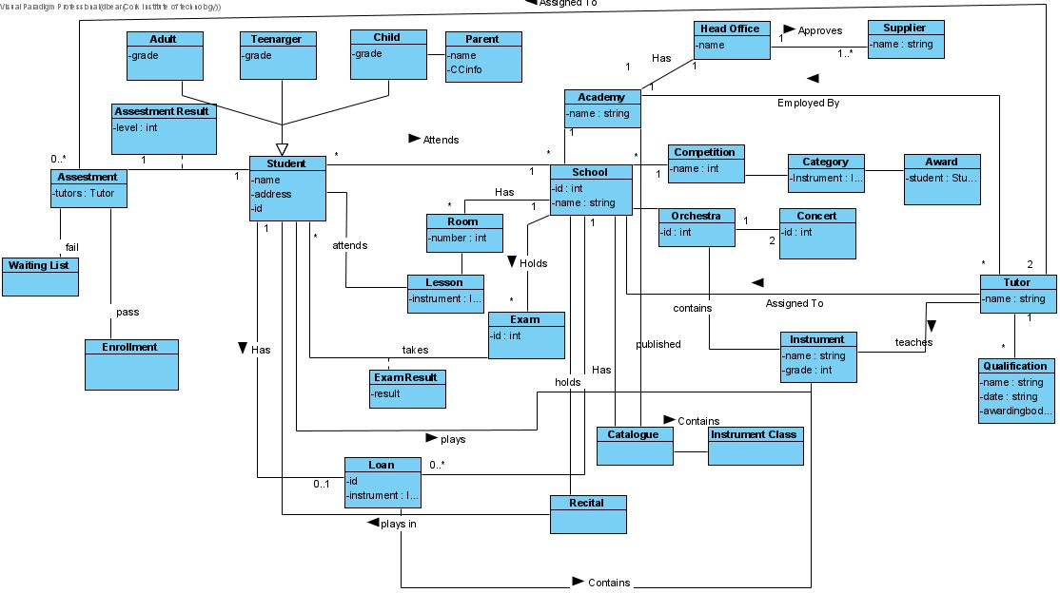

(Q2) Use case diagram illustrating all the required functionality

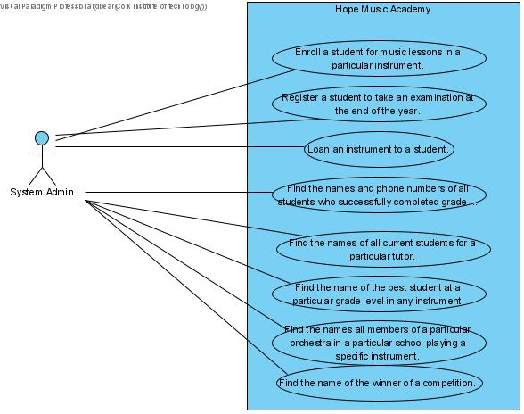

(Q3) Enrol a student for music lessons in a particular instrument (i)

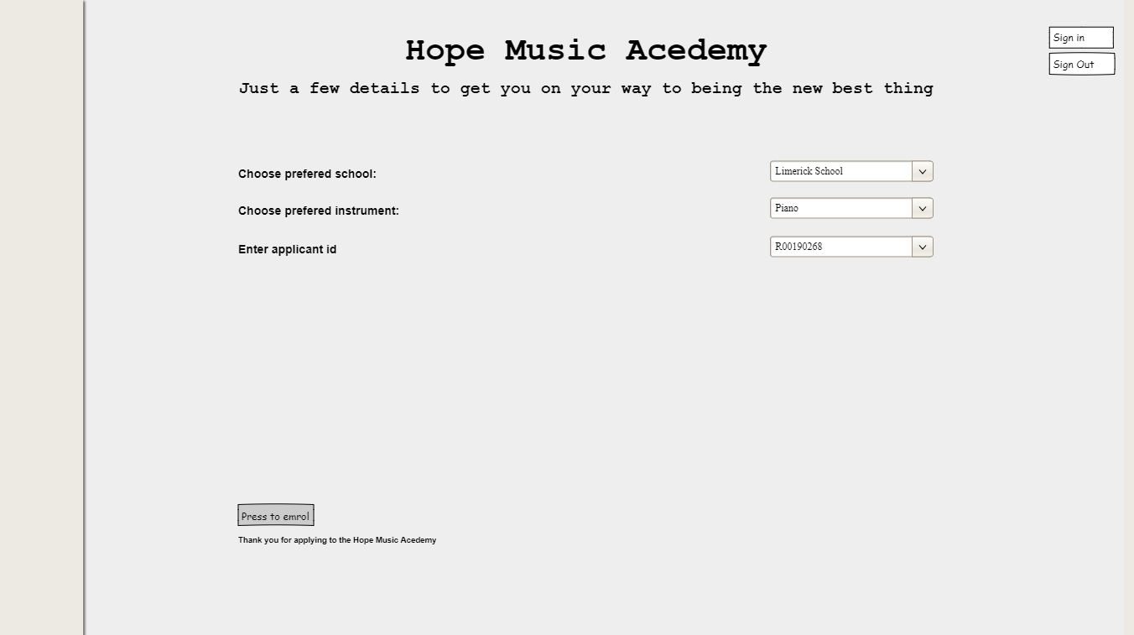(i)

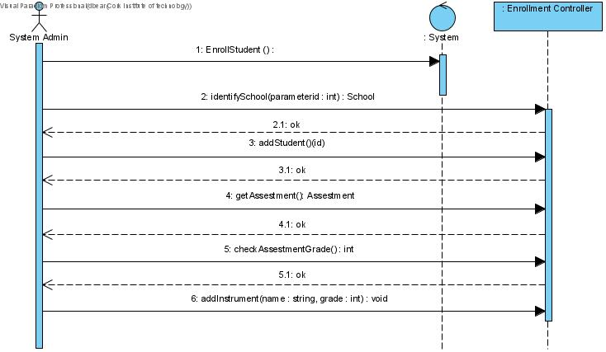(ii)

(Q3) Enrol a student for music lessons in a particular instrument (i)

(v)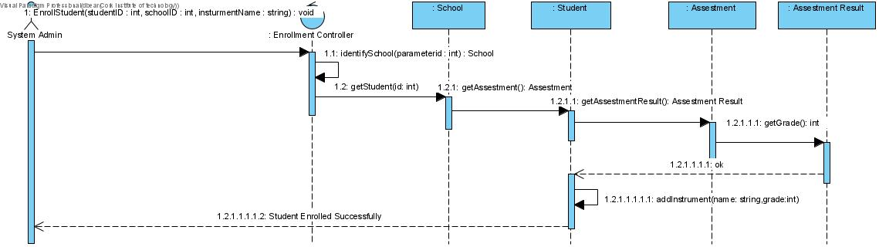

(Q3) Register a student to take an examination at the end of the year (ii)

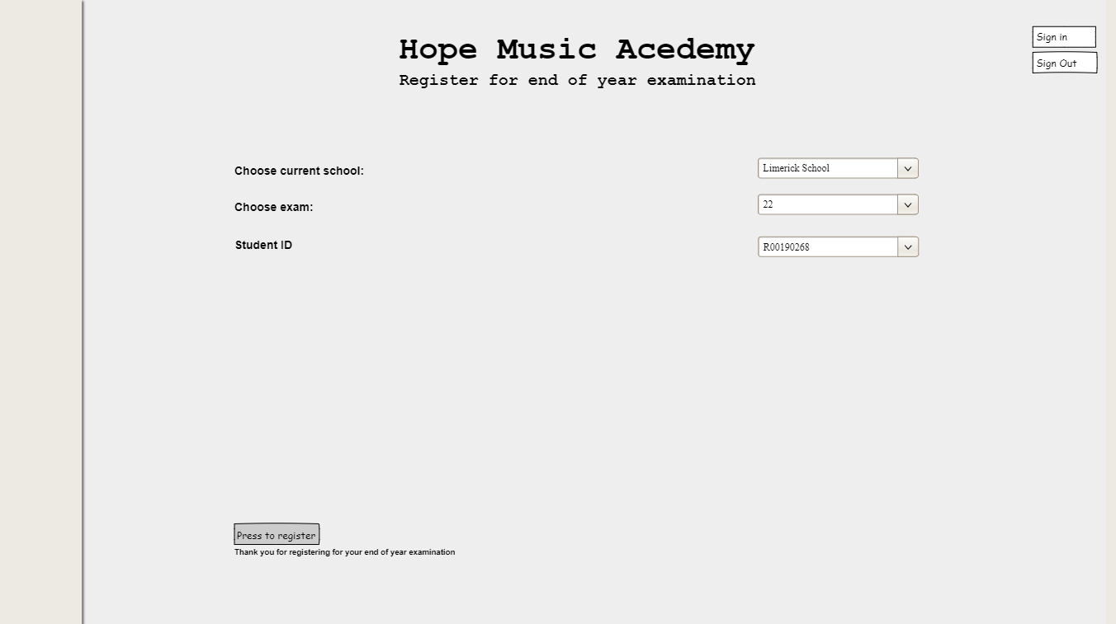(i)

(ii)

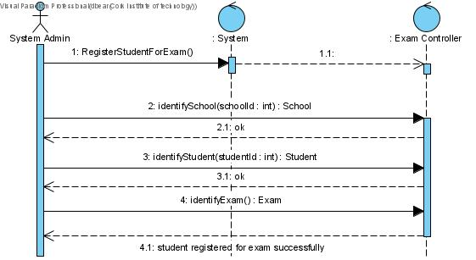

(Q3) Register a student to take an examination at the end of the year (ii)

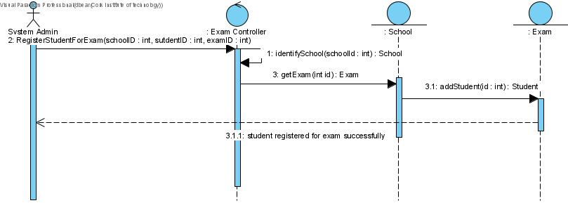(v)

(Q3) Find the names all members of a particular orchestra in a particular school playing a specific instrument. (vii)

(i)

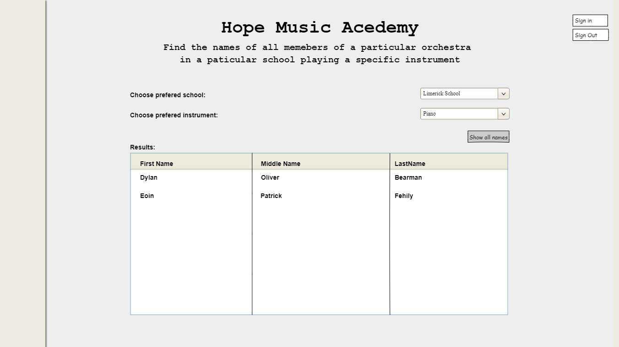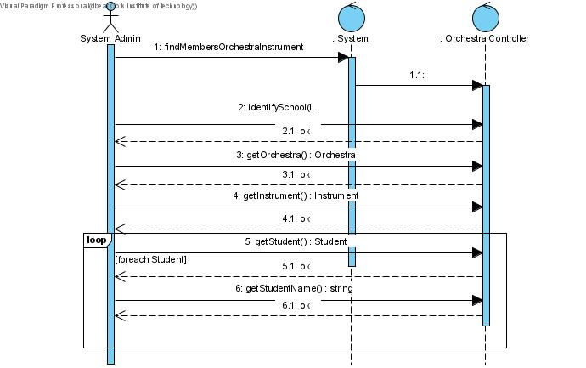

(ii)

(Q3) Find the names all members of a particular orchestra in a particular school playing a specific instrument. (vii)

(v)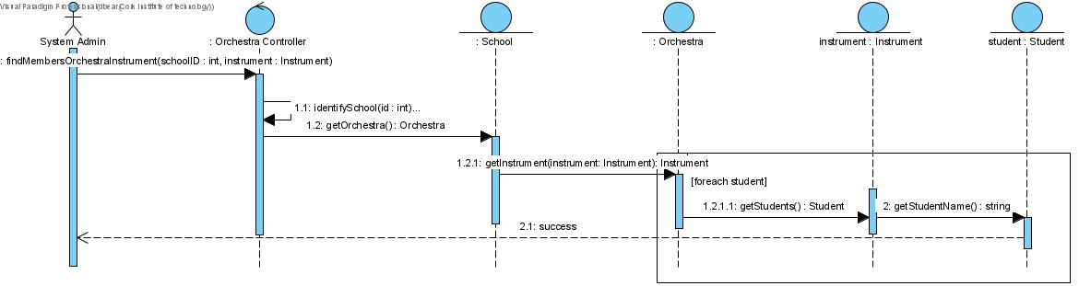

(Q3) Find the name of the winner of a competition. (vii)

(i)

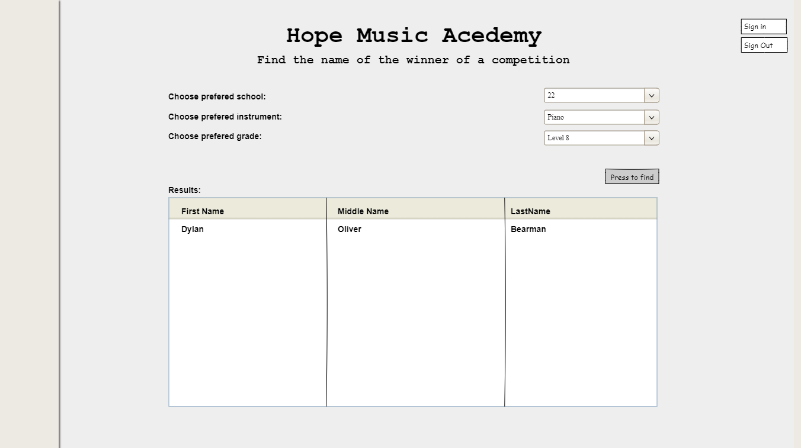

(ii)

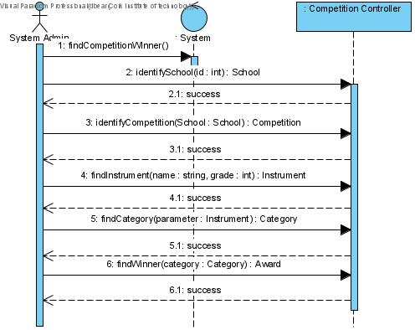

(Q3) Find the name of the winner of a competition. (vii)

(v)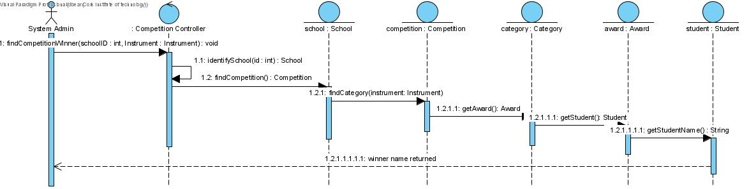

(Q4) Design class diagrams

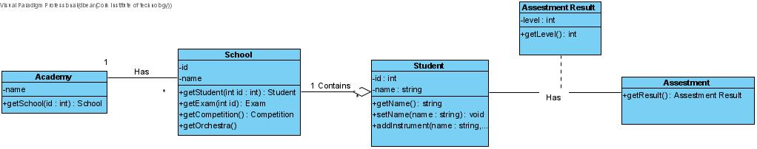Enrol a student for music lessons in a particular instrument.

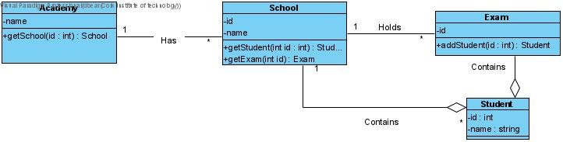Register a student to take an examination at the end of the year.

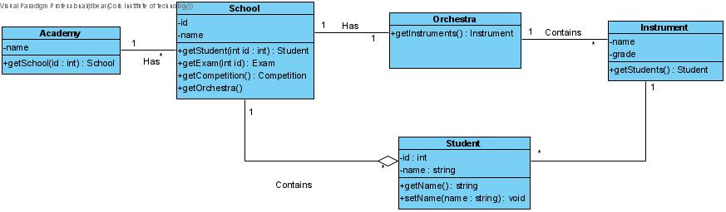Find the names all members of a particular orchestra in a particular school playing a specific instrument.

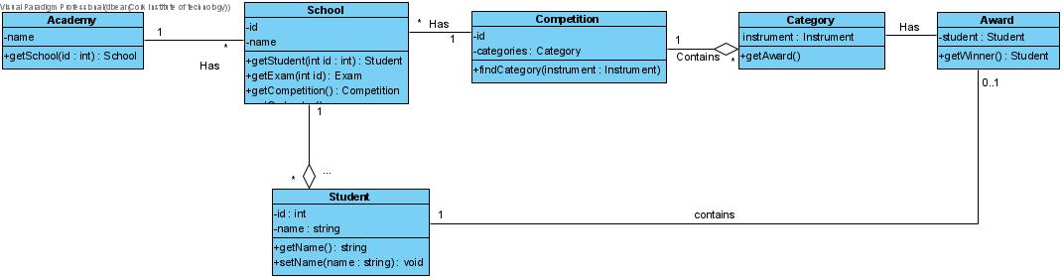Find the name of the winner of a competition.

Minutes of Meetings

MEETING1

Location: Zoom

Date: 19/04/2021

Start Time: 18:30

Finish Time: 19:30

Attendees: Dylan Bearman, Eoin Fehily

Activity Description:

1. Discussed what was required to complete the project
2. Discussed the different diagrams needed to complete the project
3. Agreed to read up and watch videos on things we weren’t sure of how to do in our own time for our next meeting
4. Kept a record of what was done to include in our log

MEETING 2

Location: Zoom

Date: 20/04/2021

Start Time: 20:00

Finish Time: 22:00

Attendees: Dylan Bearman, Eoin Fehily

Activity Description:

1. Created a domain model for the Hope Music Academy
2. Discussed which 4 of the 8 features we would complete
3. Kept a record of what we had done to include in our log

Minutes of Meetings

MEETING 3

Location: Zoom

Date: 23/04/2021

Start Time: 14:00

Finish Time: 16:00

Attendees: Dylan Bearman, Eoin Fehily

Activity Description:

1. Completed our first feature (i)
2. Completed our second feature (ii)
3. Completed our third feature (vii)
4. Kept a record of what was completed to add to our document

MEETING 4

Location: Zoom

Date: 27/04/2021

Start Time: 17:00

Finish Time: 19:00

Attendees: Dylan Bearman, Eoin Fehily

Activity Description:

1. Completed our fourth feature (viii)
2. Completed all the design class diagrams for Q4
3. Exported all the VP diagrams as images for our log
4. Made note of what we did for our word document.

Minutes of Meetings

MEETING 5

Location: Zoom

Date: 30/04/2021

Start Time: 19:00

Finish Time: 20:30

Attendees: Dylan Bearman, Eoin Fehily

Activity Description:

1. Added and cleaned up our word document
2. Saved the project to our desktop so the VP file could be uploaded
3. Recorded our presentation